Yadnesh Patil
123B1D034
Assignment No: 10
Using Map-Reduce function comply the following requirements
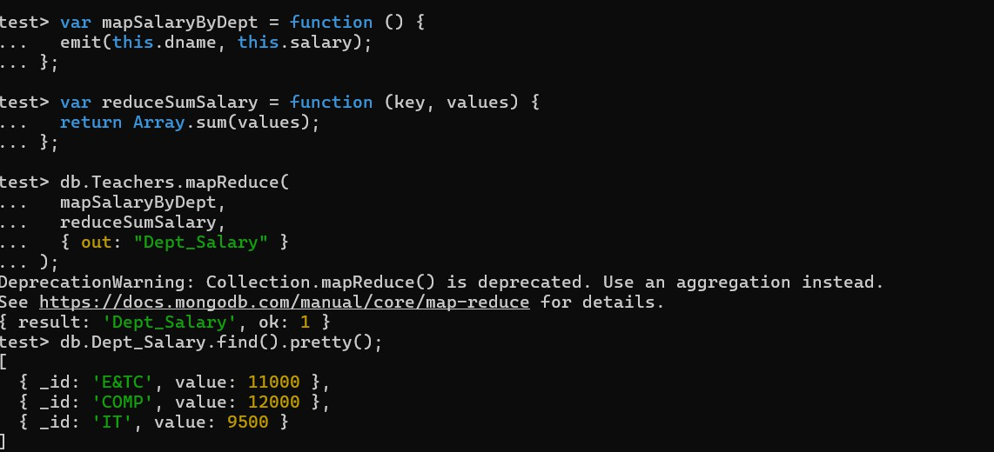
- Display the salary of employees department wise


- Display the count of employees departmentwise

- Consider the collection “Orders “ with the following types of doccuments
{
_id: ObjectId("50a8240b927d5d8b5891743c"), cust_id: "abc123",
status: 'A', price: 25,
}
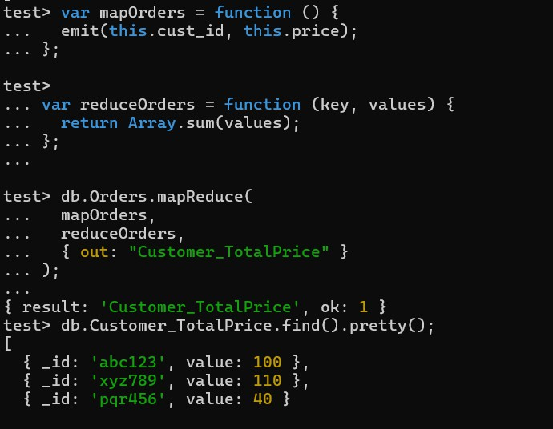
Return the Total Price Per Customer

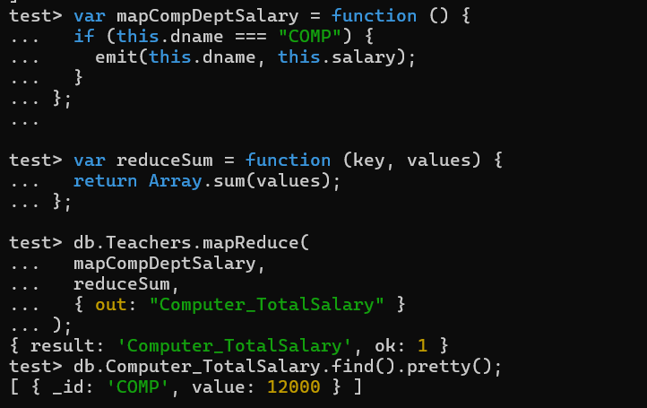
- Find the information about all teachers of computer department

- Consider each document in the zipcode collection has the following form:
{
"_id": "10280",
"city": "NEW YORK",
"state": "NY", "pop": 5574,
}
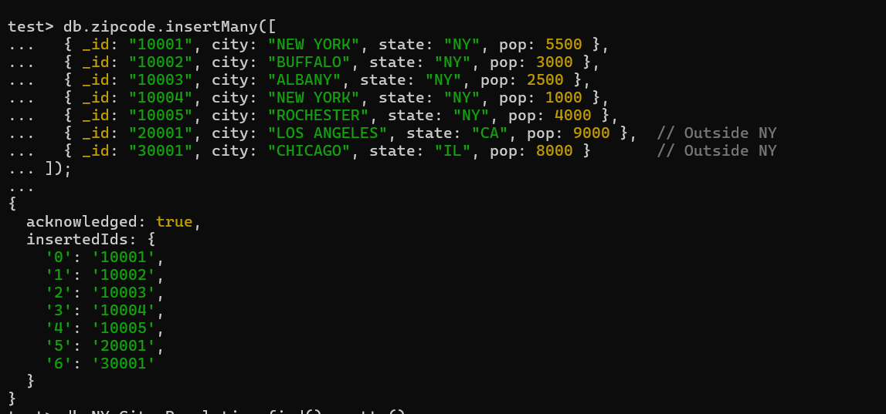
Return the city wise population of the cities in the NY state.

